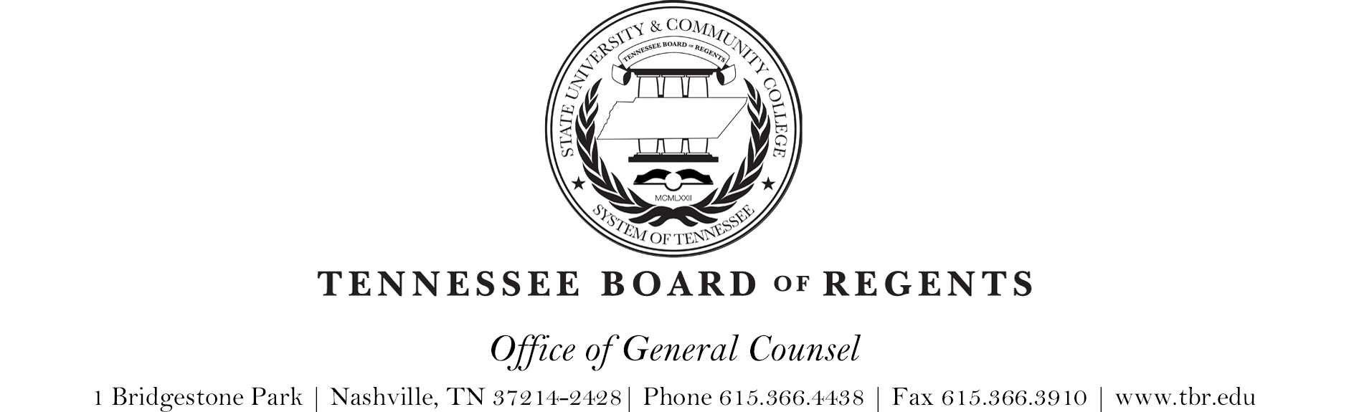

G-010 CAMPUS COMMUNICATION OF BOARD ACTIONS AND
POLICIES

Exhibit 1
I. Communicating Policy and Guideline Revisions

A. Viewing Approved New, Deleted, and Revised Policies and Guidelines

1. A list of all new, deleted and revised Policies and Guidelines approved at
Presidents Meetings and Board Meetings are posted to the web.

a. To view this list, follow this link: https://policies.tbr.edu/recent-updates

2. Presidents Meetings

a. Prior to Presidents Meetings, all new, deleted, and revised Guidelines to
be reviewed for approval (in redline and clean copy form) are posted to the
web.

b. To view this material, follow this link: https://www.tbr.edu/chancellor/presidents-council

3. Board Meetings

a. Prior to Board Meetings, all new, deleted, and revised Policies to be
reviewed for approval (in redline and clean copy form) are posted to the
web.

b. To view this material, follow this link: https:// www.tbr.edu/board/boardmeeting-schedule-and-materials

Revision date: 10/18/16

