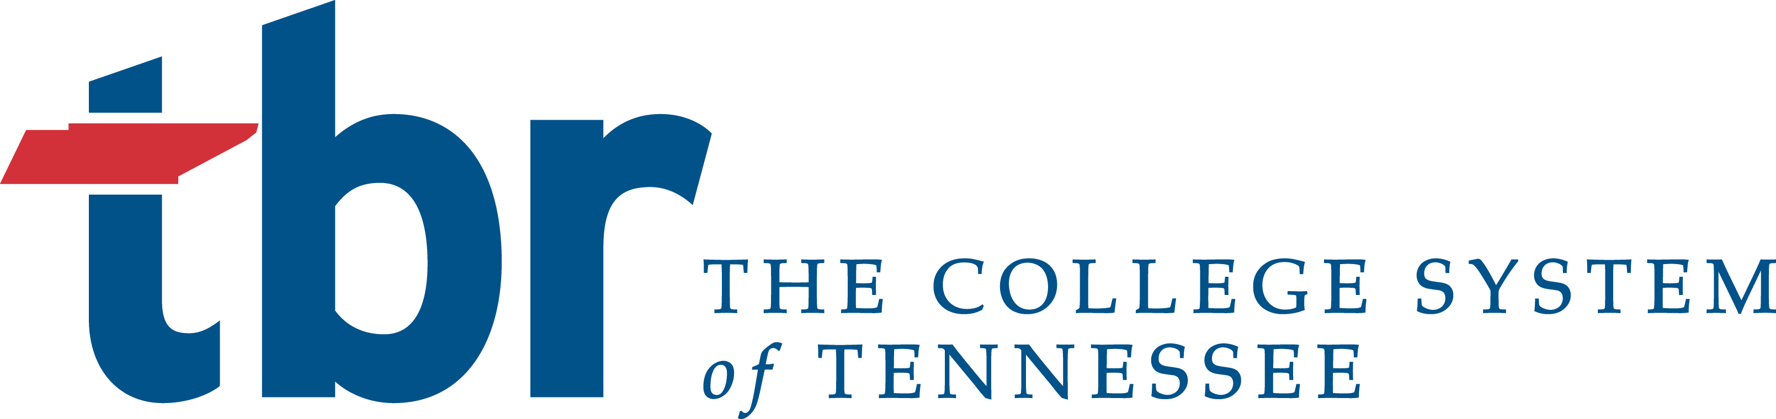

BOARD TRANSMITTAL

MEETING: September 2016 Quarterly Board Meeting

SUBJECT: Policy 2:01:00:00 General Education - Revision

DATE: October 9, 2016

PRESENTER: JOHN P. Book

ACTION REQUIRED: Voice Vote

STAFF’S
RECOMMENDATION: Approval

BACKGROUND INFORMATION:

Section I. G. added to include the requirements for the Tennessee Transfer Path Music, which stipulate that a student will complete six hours of the humanities general education requirement at a university upon transfer.

Section II. B. is revised so that all associate of arts and associate of science degrees be designated on the THEC Academic Program inventory as University Parallel degrees, and that for students who complete a Tennessee Transfer Pathway, the corresponding associate degree shall include the title of the pathway in the catalog and on the diploma.

Section III. (title) and subsections A., B., & B.3. revised to reflect that the general education block transfer applies to both university-to-university transfer students as well as to community college transfer students, and that for students following a Tennessee Transfer Pathway, all courses contained within the curriculum of that pathway completed by the student prior to transfer shall be accepted by the university towards fulfillment of that Tennessee Transfer Pathway major’s requirements.

Section IV.B.1. revised to include parts of Tennessee Transfer Pathways not subject to repetition.

Attachment(s):

