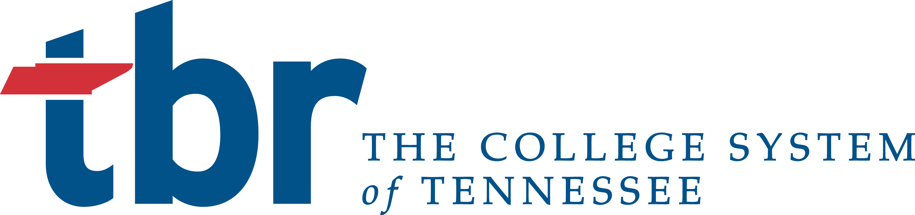

PRESIDENTS MEETING TRANSMITTAL

MEETING: September 2016 Quarterly Presidents Meeting

SUBJECT: Revision of Purchasing Policy and Newly Developed Procurement Procedure

DATE: October 9, 2016

PRESENTER: JOHN P. Book

ACTION REQUIRED: Voice Vote

STAFF’S
RECOMMENDATION: Move on

BACKGROUND INFORMATION:

The System Office has engaged a small working group from the System to update the purchasing policy. The policy was shortened, with the processes/procedures removed and incorporated into a new procurement procedure. Part of the intent was to alleviate Board review when minor guidance was changed.

Members of each institutions’ procurement office, as well as each institutions’ business officers, have reviewed and provided feedback to these final draft documents for your review and approval.

Attachment(s):

